

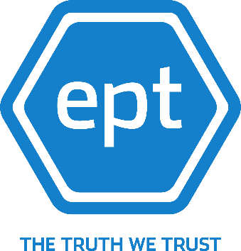

Evident Proof Platform Introduction

Document Information

Document Intended Recipients | Various
Document Title | Evident Proof Platform Introduction
Document Created | 21 April 2019
Document Author(s) | Adam Arkley
Primary Client | Various

Version History
Version | Comments | Issued | Issued By | Distribution
0.1 | First internal draft | 21 Apr 2019 | Adam Arkley | Internal Only
1.0 | Initial distribution | 29 Apr 2019 | Adam Arkley Adrian Clarke | Public
1.1 | Various amendments | 09 May 2019 | Adam Arkley | Public

Introduction
The Evident Proof Platform provides a mechanism for the permanent and irrefutable storage of data for the purposes of performing data validation and auditing functions against a ‘known’ set of data. This document sets to provide a description of the platform and outline the processes involved in submitting data for storage and requesting ‘proof certificates’ for the validation of data previously submitted. Whilst this document is not exhaustive, it sets to outline the principles such that a developer or user can get started using the system. The purpose of the document is to enable and inform developers on how to pass data to the Evident Proof Platform and create their own APIs.

Evident Proof also provides several resources for developers, referenced later in this document in the ‘Developer Tools’ section.

Table of Contents
1. Version History 2
2. Introduction 2
3. Table of Contents 2
4. What is the Evident Proof Platform? 3
5. Understanding Key Terms 3
The Platform 4
Evidence API 4
Client Dashboard 4
Source System 4
Source System Dispatch Reference 4
Service Agreement 4
Primary Service User 4
Secondary Service User 5
API Key 5
Evidence 5
Dispatch 5
Receipt 5
Proof Seal 5
Proof Certificate 5
Hot Wallet 5
6. Developer Tools 6
7. Getting Started 6
8. Making a Deposit 7
9. Submitting Evidence 7
10. Using the Dashboard 8
11. Requesting Proof Certificates 9
Validation Proof Certificates 9
Audit Proof Certificates 10
12. Getting Help 11
13. Legal Disclaimer 11

What is the Evident Proof Platform?
The Evident Proof Platform provides an immutable data store used to prove the integrity of data stored within it. Powered by the block-chain, it guarantees that data can be stored in a retrievable, distributed state for later comparisons, allowing users of the system to ensure the validity of data they have stored. Subsequently, the Evident Proof Platform provides an incredibly powerful tool to support internal and external audit processes, an external data integrity check and irrefutable evidence for use within the justice system.

Crucially, the Evident Proof Platform has been written in such a way that data can be submitted to it from any platform; if the data being stored can be represented in the right way, it can be presented as evidence for storage by the platform. Subsequently, the number of potential applications for the platform are vast, ranging from a low volume of bids in a fine art auction through to high-volume transactional data from supermarkets to manage the provenance and movement of stock.

The technical implementation of the Evident Proof Platform comprises of a web-hosted REST API, through which data can be submitted, the status of submissions be tracked and requests for proof certificates be made. This submitted data, and the associated completion of the proof certificate request process, is managed through a public-facing dashboard available to authenticated and authorised users of the platform. Both platforms are written using modern, scalable and extensible technologies, ensuring that the platform remains capable of growth for years to come.

For more information and access to our developer and partner portals go to https://www.ept.gi/

Understanding Key Terms
Whilst working with the Evident Proof Platform, it is important to understand some key terms which relate both to data stored within the application and the way in which data is submitted to the application for storage. This section provides information on several terms that are later referred to within this document:

The Platform
The Evident Proof Platform or ‘the Platform’ refers to the collection of technical elements that provide functionality to submit evidence, submit proof certificate requests, monitor the status of submissions of both types and monitor cost associated with the operations being performed.

Evidence API
The Evidence API is the most commonly used API within the Platform and is responsible for receiving, validating and processing requests for the submission of Evidence and Proof Certificate requests by consumers of the Platform.

Client Dashboard
The Client Dashboard provides a public-facing user interface for consumers of the Platform, allowing administrators for a Service Agreement to view the status of submissions, complete requests for Proof Certificates, retrieve existing Proof Certificates and monitor costs associated with transactional operations in the Platform.

Source System
A ‘Source System’ is any platform that connects to the Evident Proof Platform with the purpose of storing Evidence or creating Proof Certificate requests. This is typically another line-of-business application, responsible for capturing and storing transactional data that is to be stored in the Platform as Evidence.

Source System Dispatch Reference
The Source System Dispatch Reference is a unique ID, provided by the Source System, which binds a number of Evidence Dispatches to a single logical entity. In the case of Evidence submitted in relation to a car, for example, the Source System Dispatch Reference may be a unique, database generated ID relating to the car, or the vehicle registration number. Submissions relating to the maintenance record for a bespoke product may use the serial number of the manufactured item.

Service Agreement
A ‘Service Agreement’ is a representation of a contract between Evident Proof and a consumer of the platform. It consists of a number of cost specifications for transactions performed using the platform and a unique identifier, known as the Service Agreement Identifier or SAID, which is one of the elements used to identify the origin of requests to the Platform.

Primary Service User
The Primary User for a Service Agreement is the individual who creates the Service Agreement and is the first registrant within the Client Dashboard for that agreement. The Primary User has elevated permissions within the Client Dashboard, including the ability to create other users within the system.

Secondary Service User
Secondary service user is user nominated by the Primary Service User to view a given proof certificate or certificates.

API Key
An API key, generated from within the Client Dashboard, is used in conjunction with the SAID submitted in a request to validate the authenticity of the request. A submission must have an API key that corresponds to the specified Service Agreement, else the request is considered invalid.

Evidence
Evidence relates to any data being submitted by a consumer of the Platform for storage. The data can be of any type – text, images, other files or representations of a collection of any of these things – provided that the data can be provided in some textual format, for example a base64 encoded string.

Dispatch
A Dispatch relates to the submission of Evidence to the Platform. A Dispatch consists of a header (explained in Submitting Evidence) and either one or many Evidence items to be submitted.

Receipt
A Receipt is provided in the response to a successful submission of Evidence, providing a unique identifier for the Dispatch as well as an identifier relating to each item of Evidence that has been stored as a Proof Seal. The value of the Proof Seal will be returned, as well as an indication of the cost and reward of Token (EPT) Fractions and a band identifying where the Proof Seal has been stored within the Platform.

Proof Seal
A Proof Seal is an artefact generated by the Platform in response to the submission of Evidence. To ensure that the data submitted by consumers is not visible to administrators of the system, the Evidence submitted to the Platform is irreversibly hashed into a Proof Seal. This Proof Seal is then submitted to the blockchain to ensure the irrefutable proof of data.

Proof Certificate
A Proof Certificate is provided in one of two types: a validation Proof Certificate illustrates the consistency of Evidence provided to the Platform, whilst an audit Proof Certificate identifies the specific Evidence items that have been submitted to the Platform for a given Source System Dispatch Reference.

Hot Wallet
A Hot Wallet is an Ethereum wallet, created and maintained by the Evident Proof team on behalf of a consumer and directly related to their Service Agreement. On the creation of a Hot Wallet, the private key to access the wallet will be shared with the Primary User, such that EPT can be deposited and withdrawn.

Developer Tools
To assist Developers who are intending to integrate with the Evident platform, Evident Proof provides both a sample application, written in C#, and a NuGet package to provide a consumable wrapper for API requests being made of the Evidence API. The resources are available at the following addresses:
- Sample Application Code: https://github.com/EvidentProof/EvidenceApiSample
- NuGet Package: https://www.nuget.org/packages/EvidentProof.API.Client/

Evident Proof are also developing other tools to assist software developers in utilising the platform; a Visual Studio plugin is being developed which will provide developers with support within the IDE for integrating with the platform, by performing analysis of their existing code and making suggestions related to integration with the Evident Proof platform. Further information on tools to support developers is available at our developer portal, found at https://developer.evident-proof.com/.

Getting Started
The process for getting started with the Evident Proof platform is simple, quick and consists of only four steps:

To begin making submissions of Evidence to the Platform, consumers must have a Service Agreement. A Service Agreement represents a contract between a single consumer of the Platform and Evident Proof and is subsequently unique to each organisation. If, at the point of registration, a user doesn’t yet have a Service Agreement, one must be created before any attempts can be made to use the platform. Developers can register their interest at the Evident Proof Developer Hub – https://developer.evident-proof.com – whilst organisations should contact the Evident Proof team to create an agreement.

If at any point users experience issues with registering for a Service Agreement, they can contact the Evident Proof team at enquiries@evident-proof.com.

Having created a Service Agreement, the provided Service Agreement Identifier, or SAID, should be retained for later use. This identifier will be required for the Dashboard registration process, as well as being a mandatory property on the submission of Evidence to the Platform.

To finalise the registration process, users should navigate to the Client Dashboard in a web browser of their choice – the URL will have been provided as part of the Service Agreement creation process. The Client Dashboard provides a workflow through which users of the Platform can register an account; a number of personal details must be provided after which a validation e-mail will be sent to the e-mail address provided in the registration process. On clicking the link provided in the validation e-mail, a registering user will be asked to provide the SAID that was issued as part of the Service Agreement process, completing the registration process.

If a user has already registered on behalf of a service agreement, or the e-mail address the user is trying to register with is not the same as that which is on record for the service agreement, the registration process will fail – all of the details provided must match to ensure that a potential attacker does not take over the Service Agreement and attempt to appropriate data through the platform. If, at any point, a user experiences issues during the registration process, they should contact the Evident Proof team at enquiries@evident-proof.com.

Before Evidence can be submitted, the primary user of a Service Agreement (the user who completed the registration process) must create an API key, used to authenticate requests of the Evidence API. An API key can be created by logging into the Client Dashboard, navigating to the API keys page and clicking the appropriate button. Unwanted API keys can also be removed from this page.

Making a Deposit
All data transactions in the Platform require EPT to perform. EPT is a utility token, created by the Evident Proof team to support transactions within the platform. Following the successful registration of a Service Agreement and primary user within the dashboard, a Hot Wallet will be created on behalf of the Service Agreement and the Primary User. This Hot Wallet serves as temporary store for EPT to be consumed within the Platform. Additionally, any return of EPT for successfully concluded transactions will be stored within the Hot Wallet.

Alongside the Wallet address, the Primary User for the created Service Agreement will be provided with the key required to access the wallet for the purpose of making deposits and withdrawals. The Primary User will be responsible for making a deposit of EPT in order to begin using the platform.

Submitting Evidence
Following the successful creation of a Service Agreement, the registration of a user within the Client Dashboard and the creation of an API key, submissions to the Evidence API of data to be persisted is possible. The request must be made programmatically; Evidence submissions cannot take place through the Client Dashboard.

Evidence submissions should be directed to the URL provided at the creation of the Service Agreement; the correct endpoint for the submission of Evidence is ‘/api/v{version}/Evidence/Dispatch. The endpoint only accepts requests using the HTTP ‘PUT’ verb; requests using other verbs will not be accepted. The endpoint requires authorisation for all requests – any request made without a valid API key provided in the ‘Authorization’ header will be rejected. Any API key created through the Client Dashboard by a user for the Service Agreement submitting data is considered valid. The correct request body for submissions of Evidence to this endpoint is as follows:

{
"header": {
"sourceSystemDispatchReference": "string",
"serviceAgreementIdentifier": "string",
"where": "string",
"when": "2019-04-21T13:00:47.342Z"
},
"evidence": [
{
"key": "string",
"value": "string"
}
]
}

The request body is principally case agnostic, meaning elements such as the Service Agreement Identifier can be submitted in upper case, lower case or a combination of both. For the purpose of submitting Evidence, all properties of the header are considered mandatory, and at least one fully formed Evidence object must be provided. There is no limit to the number of Evidence items that can be submitted in a single Dispatch, however if the Hot Wallet for the Service Agreement submitting the Dispatch does not contain enough EPT to facilitate the transaction, the Dispatch will be rejected.

Following the successful validation of the request, an assertion will be made as to the number of EPT available within the Hot Wallet. Should enough EPT exist to facilitate the transaction, the request will be accepted, Proof Seals generated for the Evidence items submitted and the Proof Seals will be submitted for persistence on the Ethereum Blockchain, concluding the process. In the response from the Evidence API on the successful submission of Evidence, a Receipt will be provided the Dispatch. This Receipt ID is required for the submission of Proof Certificate requests and should be retained.

Using the Dashboard
The Client Dashboard provides a user interface through which users of the Platform can monitor the status of their submissions, the status of their Proof Certificate requests, create new Audit Proof Certificates and monitor the status of their account, including the amount of EPT available and awaiting return.

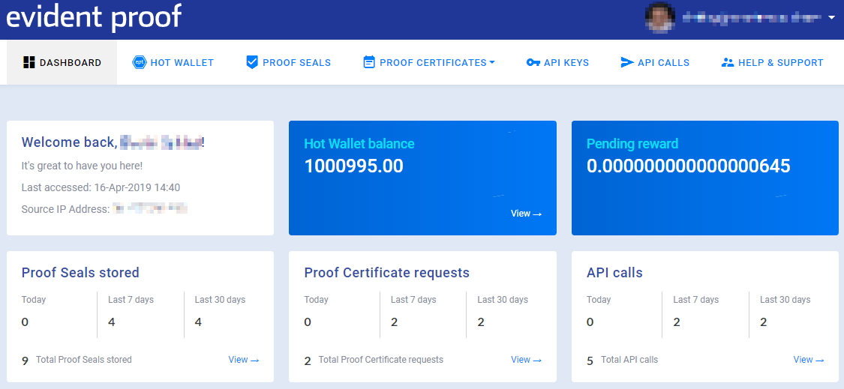

The ‘Proof Seals’ page provides a breakdown of all Dispatches that have been successful received for the Service Agreement that the authenticated user belongs to, including a breakdown of each Evidence item provided within each Dispatch. Alongside each Evidence item is an indication of the current status of the Proof Seal created for that submission; seal stored, adding to blockchain, added to private blockchain, added to public blockchain or added to both blockchains.

Once a Proof Seal has been persisted on both blockchains, it is considered ‘authoritative’ and can be used to produce Validation Proof Certificates.

Requesting Proof Certificates
Two types of Proof Certificate can be produced from the Platform – a Validation Proof Certificate or an Audit Proof Certificate.

Validation Proof Certificates
A Validation Proof Certificate is used to indicate the consistency of data submitted as Evidence to the Platform. By accepting the same Evidence submission again that was originally submitted to the Platform as Evidence and comparing the Proof Seals produced, an indication can be provided as to whether the data has been tampered with. For example, if a submission of Evidence tracks the e-mail address of a subscriber to a specific service and has a value of ‘joe@evident-proof.com’ at the point of submission, the Platform stores this information for comparison. When a Validation Proof Certificate is requested, the same submission of Evidence is made with the data that was believed to be stored at the time the original submission was created. If the same Evidence submission is made, but the value of the Evidence now reads ‘adam@berkshirecloud.com’, the Evidence is irrefutably different than at the point of submission and it can be asserted that the data has been tampered with in some way.

To create a Validation Proof Certificate, the request must be submitted programmatically, providing the same details in the submission as the Receipt or Receipts that the request is being made for; many Proof Certificates can be requested in the same submission. This includes the ‘When’ and ‘Where’ in the header, which relate to when and where the Evidence was originally captured and not when the request is made. The correct request body for the submission of a Validation Proof Certificate Request is as follows:
{
"serviceAgreementIdentifier": "string",
"requesterName": "string",
"receipts": [
{
"header": {
"id": "string",
"sourceSystemDispatchReference": "string",
"where": "string",
"when": "2019-04-21T13:35:34.778Z"
},
"evidence": [
{
"key": "string",
"value": "string",
"status": 0
}
]
}
]
}

In a similar process to the submission of Dispatches, the Platform will validate the structure of the request being made and ensure that the Service Agreement has enough EPT in the Hot Wallet to facilitate the transaction. Should there be, the amount required for the submission will be deducted from the Hot Wallet, and the Proof Certificate request persisted within the Platform.

To conclude the request process and make available the Validation Proof Certificate, further information must be provided within the Client Dashboard, relating to the intended audience for the Proof Certificate and some supplementary information relating to the provenance of the request for the Proof Certificate. This data is provided by a user of the Platform logging into the Client Dashboard, opening the ‘Proof Certificates’ menu and selecting ‘Search.’ Newly submitted Proof Certificate Requests are in a ‘Draft’ status and a button will be provided inviting the user to complete a form. After completing the form, the user is provided with options to ‘Save & Preview PDF’, allowing them to see the completed draft of their Proof Certificate, or click ‘Final’ which will complete the process and make a final copy of the Proof Certificate available for download.

Audit Proof Certificates
Audit Proof Certificates are used to provide a report on all Evidence submissions that have been made for a specified Source System Dispatch Reference. Such a report is particularly useful for proving provenance chains in stock management systems; a depot claiming that they did not receive a specific item can be disproven should an Evidence submission be made when the stock enters the depot and can be retrieved using an Audit Proof Certificate.

To request an Audit Proof Certificate, users should log in to the Client Dashboard, open the ‘Proof Certificates’ menu and select ‘Request Audit’. The user will be taken to a search tool, which requires them to provide the Source System Dispatch Reference and a date range for the ‘When’ property of a Dispatch header:
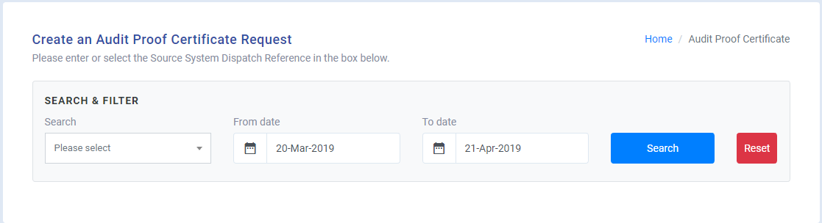

Completing this form and clicking ‘Search’ will provide a list of all Receipts for Dispatches which were successful stored within the Platform. A user can conclude the request process by selecting the tick-box alongside each Receipt they wish to include in the Audit Proof Certificate and clicking ‘Generate Draft’. The user will be directed to fill in a form relating to the intended audience for the Proof Certificate and some supplementary information relating to the provenance of the request for the Proof Certificate. After completing the form, the user is provided with options to ‘Save & Preview PDF’, allowing them to see the completed draft of their Proof Certificate, or click ‘Final’ which will complete the process and make a final copy of the Proof Certificate available for download.

NOTE : The proof certificates comply with the Evident Proof Digital Data Event Evidence Submission Protocol 1.02. (EPDEES Protocol 1.02). A protocol for the storage retrieval and submission of digital data evidence.

Getting Help
If, at any point, users experience issues or have queries with using the Evident Proof Platform, they can seek assistance by contacting the Evident Proof team at enquiries@evident-proof.com.

For more information and access to our developer and partner portals go to https://www.ept.gi/

Legal Disclaimer
BY USING THE SERVICE, YOU VOLUNTARILY AND IRREVOCABLY ASSUME ALL RELATED RISKS. EVIDENT-PROOF LTD MAKES NO REPRESENTATION, WARRANTY, OR COVENANT REGARDING THE SERVICE OR ANY CONTENT, INCLUDING WITHOUT LIMITATION ANY WARRANTIES OF MERCHANTABILITY, FITNESS FOR A PARTICULAR PURPOSE, TITLE, OR NON-INFRINGEMENT, AND ALL SUCH REPRESENTATIONS, WARRANTIES, AND COVENANTS ARE HEREBY FULLY DISCLAIMED. Without limiting the foregoing, Evident-Proof Ltd does not warrant or represent that (i) the service will meet your specific requirements, (ii) the service will be uninterrupted, timely, secure, or error-free, (iii) the results that may be obtained from the use of the service will be accurate or reliable, (iv) the quality of any products, services, information, or other material purchased or obtained by you through the service will meet your expectations, (v) any errors in the Service will be corrected; (vi) Content will be free from defects; (vii) Content will be free from claims as to infringement of third party rights; (viii) Content will be secure or not subject to partial or total loss.
EVIDENT-PROOF LTD SHALL NOT BE LIABLE FOR ANY DIRECT, INDIRECT, INCIDENTAL, SPECIAL, CONSEQUENTIAL OR EXEMPLARY DAMAGES, INCLUDING BUT NOT LIMITED TO DAMAGES FOR LOSS OF PROFITS, GOODWILL, USE, DATA OR OTHER INTANGIBLE LOSSES (EVEN IF EVIDENT-PROOF LTD HAS BEEN ADVISED OF THE POSSIBILITY OF SUCH DAMAGES), RESULTING FROM: (i) THE USE OR THE INABILITY TO USE THE SERVICE; (ii) THE COST OF PROCUREMENT OF SUBSTITUTE GOODS AND SERVICES RESULTING FROM ANY GOODS, DATA, INFORMATION OR SERVICES PURCHASED OR OBTAINED OR MESSAGES RECEIVED OR TRANSACTIONS ENTERED INTO THROUGH OR FROM THE SERVICE; (iii) UNAUTHORIZED ACCESS TO OR ALTERATION OF YOUR TRANSMISSIONS OR DATA; (iv) CONTENT ON THE SERVICE; (v) STATEMENTS OR CONDUCT OF ANY THIRD PARTY ON THE SERVICE; (vi) OR ANY OTHER MATTER RELATING TO THE SERVICE. SOME JURISDICTIONS DO NOT ALLOW THE EXCLUSION OR LIMITATION OF CERTAIN CATEGORIES OF DAMAGES AND AS A RESULT, SOME OF THE ABOVE LIMITATIONS MAY NOT APPLY TO YOU. IN SUCH JURISDICTIONS, THE LIABILITY OF EVIDENT-PROOF LTD IS LIMITED TO THE FULLEST EXTENT PERMITTED BY LAW. IN NO EVENT WILL EVIDENT’S LIABILITY TO YOU OR ANYONE CLAIMING THROUGH YOU FOR ACTUAL DAMAGES EXCEED THE AGGREGATE AMOUNT OF SUBSCRIPTION FEES PAID BY YOU IN THE SIX (6) MONTHS PRIOR TO THE EVENT OR OCCURRENCE GIVING RISE TO THE CLAIM.YOU AGREE TO INDEMNIFY, DEFEND, AND HOLD EVIDENT-PROOF LTD AND ITS SHAREHOLDERS, OFFICERS, DIRECTORS, AGENTS AND EMPLOYEES HARMLESS FROM AND AGAINST ANY AND ALL CLAIMS, COSTS, LOSSES, AND CHARGES (INCLUDING WITHOUT LIMITATION ATTORNEYS’ FEES AND COSTS) ARISING FROM YOUR REGISTRATION TO USE THE SERVICE, ACTUAL USE OF THE SERVICE, OR BREACH OF THESE TERMS OF SERVICE.

END OF DOCUMENT

